**FULL STACK PROJECT**

**SYNOPSIS**



**Department of Computer Science & Application**

**Institute of Engineering & Technology**

**TOPIC: Hostel Booking Website**

**SUBMITTED BY:- SUBMITTED TO:-**

Srashti Shukla Mr. Akash Kumar Choudhary

(201500706) (Technical Trainer)

**DECLARATION**

I here by declare that the work which is being presented in the Full Stack Project "Hostel Booking Website", in partial fulfilment of the requirements for Full Stack Project, is an authentic record of my own work carried under the supervision of :

Mr. Akash Kumar Choudhary,

(Technical Trainer)

GLA University, Mathura.

Srashti Shukla (201500706)

Sign: _____________

Course: B. Tech (CSE)

Year: 3rd

Semester: VI

**ACKNOWLEDGEMENT**

It gives us a great sense of pleasure to present the synopsis of the B-Tech Full Stack project undertaken during B-Tech III Year VI sem. This project is going to be an acknowledgement to the inspiration, drive and technical assistance will be contributed to it. I owe special debt of gratitude to Mr. Aaksh Kumar Choudhary , Technical Trainer , for providing us with an encouraging platform to develop this project, which thus helped us in shaping our abilities towards a constructive goal and for his constant support and guidance to our work.

His sincerity, thoroughness and perseverance has been a constant source of inspiration for us. We believe that he will shower us with all his extensively experienced ideas and insightful comments at different stages of the project & also taught us about the latest industry-oriented technologies. We also do not like miss the opportunity to acknowledge the contribution of all faculty members of the department for their kind guidance and co-operation.

Srashti Shukla

(201500706)

**CONTENTS**

Declaration

Acknowledgement

1. Introduction

2. System Requirements

2.1 Hardware Requirements

2.2 Software Requirements

3.Front-end and Back-end

4. Objective

5. Description

6. Implementation

7.DFD (0level 1 level and 2 level)

8. Bibliography

9. References

**INTRODUCTION**

A hostel booking application built using the MEAN stack (MongoDB, Express js, Angular js, and Node.js) can offer a robust solution for managing reservations and student data. The application can have two main components: a front-end user interface and a back-end API.

The front-end can be built using Angular, which can provide a smooth user experience and allow users to search for hostels, view photos, and book rooms.

The back-end can use Node.js and Express js to build a RESTful API, which can handle user authentication, handle bookings, and interact with the MongoDB database.The MongoDB database can store guest data, hostel information, room availability, and booking details.

The application can have several features such as student login, booking management, availability tracking, and payment processing.To summarize, a hostel booking application built using the MEAN stack can provide a scalable and efficient solution for hostel owners to manage their business and for Students to book rooms quickly and easily.

**Primary Reason to Choose This Project**

Many Students, particularly budget-conscious backpackers, face difficulty in finding and booking affordable and comfortable accommodation while traveling to new places. This is often due to the lack of easily accessible and reliable information about hostels, including their availability, pricing, and amenities. Additionally, hostel owners may have limited resources and may struggle to market their properties effectively to attract new customers. This can lead to a gap in the market, where Students are left with limited options for budget-friendly accommodation, and hostel owners struggle to fill their rooms and increase their revenue.

A hostel booking website can help address this problem by providing a comprehensive and reliable platform that connects students with a wide range of affordable and comfortable hostels in various destinations. The website should have an easy-to-use interface, where users can search and filter hostels based on their preferences, read reviews, compare prices, and make bookings quickly and securely. It should also provide a platform for hostel owners to promote their properties, manage their bookings, and receive payments seamlessly.

In summary, the problem statement for a hostel booking website is to provide a comprehensive, reliable, and user-friendly platform that connects budget-conscious students with affordable and comfortable hostels while also supporting hostel owners to promote their properties and increase their revenue.

**Literature Survey / Feasibility Study**

A literature survey or feasibility study of a hostel booking website involve researching existing platforms and evaluating their success, as well as identifying potential challenges and opportunities for a new website. Here are some key points to consider:

1. Market research: Conducting market research to identify the demand for a hostel booking website, as well as the potential user base and target audience. This research should also identify any gaps or unmet needs in the market that a new website could address.
2. Competitor analysis: Conducting a thorough analysis of existing hostel booking websites to identify their strengths and weaknesses. This analysis should evaluate the user experience, features, pricing, and customer reviews of each platform. This can provide valuable insights into what works and what doesn't in the market, as well as potential areas for improvement.
3. Technical feasibility: Evaluating the technical feasibility of developing a hostel booking website, including the required infrastructure, programming languages, and hosting options. This feasibility study should also consider potential data privacy and security concerns, as well as compliance with relevant regulations.
4. Business model: Identifying potential revenue streams for the hostel booking website, such as commissions on bookings, paid advertisements, or premium features. This feasibility study should also evaluate the potential costs of running the website, including marketing, development, hosting, and customer service.
5. User experience design: Developing user personas and conducting user testing to identify the features and functionality that users are looking for in a hostel booking website. This can include factors such as ease of use, speed, mobile responsiveness, and search functionality.
6. Marketing and promotion: Identifying potential marketing channels and strategies to promote the hostel booking website to potential users. This feasibility study should consider factors such as social media, search engine optimization, and partnerships with hostels or travel agencies.

Overall, a literature survey or feasibility study of a hostel booking website should provide a comprehensive evaluation of the market, technical requirements, potential revenue streams, and user experience of a new platform. This can help to identify potential challenges and opportunities, as well as inform the development and marketing of the website.

**Future Scope**

The future scope of a hostel booking website can be quite promising, as the travel and tourism industry is expected to continue growing in the coming years. Here are some potential areas for growth and development in this field:

1. Mobile Optimization: With the increasing usage of smartphones, having a mobile-optimized website can help attract more users to your hostel booking platform. This means the website must be designed to fit well on the smaller screens of smartphones and be easy to use.
2. Enhanced User Experience: Providing a better user experience through improved website design, speed, and features can attract more customers. Some features that can be added to enhance the user experience include 3D virtual tours of hostels, easy and secure online payment options, and personalized recommendations based on previous bookings.
3. Personalization: Personalized experiences can be created through the use of data analytics to understand customer behavior and preferences. This can help in making customized recommendations for hostels and other travel-related services.
4. Social Media Integration: Integrating social media platforms like Facebook, Instagram, and Twitter into the hostel booking website can help users get a better idea of the hostels they're interested in by seeing reviews and pictures posted by other students.
5. Expansion of Services: Expanding services beyond just hostel booking, such as providing airport transfers, booking tours and activities, and offering travel insurance can add value and convenience for customers.

Overall, the future scope of a hostel booking website is vast and full of potential. As long as the website is updated and modernized to meet the needs and preferences of students, it can continue to grow and expand its services.

**SYSTEM REQUIREMENTS**

**Software Requirements:-**

1. User Interface Design : HTML , CSS & JS
2. Web Browser : Google Chrome and Microsoft Edge
3. Front end : HTML , CSS & JS
4. Back end : MongodB, Node js, Express Js

**Hardware Requirements:-**

1. Windows 11
2. 512 MB Ram
3. VS Code
4. Ethernet Adapter
5. GitHub

**Frontend and Backend**

**Frontend :-**

The front end is the part of the website a user or customer interacts with. A lot goes into making the frontend work, including database architecture, frameworks, scaling solutions, and more. It includes: Styles: This includes the buttons, layouts, inputs, text, images, and more.

1. HTML :

HTML stands for Hypertext Markup Language. It is a markup language used for creating web pages and other types of documents that are intended to be displayed in a web browser. HTML is used to structure and format content, such as text, images, videos, and other multimedia elements, on a web page.

1. CSS :

CSS stands for Cascading Style Sheets. It is a style sheet language used for describing the visual presentation of a web page or document written in HTML or other markup languages. CSS is used to control the layout, formatting, typography, and other aspects of a web page's appearance.

1. Angular JS :

AngularJS is an open-source, front-end web application framework developed by Google. It is a popular framework used for building dynamic web applications. AngularJS extends HTML by adding new attributes and directives to create a more dynamic and responsive user experience.

**Backend:-**

The back end is a combination of servers and databases. Servers control how users access files. Databases are organized and structured collections of data.

1. MongoDB :

MongoDB is a cross-platform, document-oriented, NoSQL database that uses a JSON-like format for storing and retrieving data. It is an open-source database system that is designed to be scalable, flexible, and fast. MongoDB stores data in documents that are organized into collections, rather than tables in a traditional relational database.

1. Express JS :

ExpressJS, often simply called Express, is a popular web application framework for Node.js. It provides a set of tools and features for building web applications and APIs, with a focus on simplicity and flexibility.

1. Node JS :

Node.js is an open-source, cross-platform, JavaScript runtime environment that allows developers to build scalable, high-performance applications using JavaScript. It is built on the V8 JavaScript engine from Google, and provides a server-side runtime environment for running JavaScript code outside of the web browser.

**OBJECTIVE**

The objective of this project is to create an e-commerce web portal with a content

management system which would allow product information to be updated securely using

a mobile device.

The web portal will have an online interface in the form of an e-commerce website that

will allow users to buy goods from the merchants.

The e-commerce portal will have the following key features:

● An online shop that will allow online shoppers to buy wares from formal and

informal merchants.

● A search engine on the website to allow customers to find specific types of

merchandise.

●A secure online transaction system that will allow shoppers to purchase goods

safely using their credit cards.

●A database of merchandise with photos, product descriptions and stock

information. This database will also contain all relevant merchant and customer

information.

●A data security system that will ensure that all data that is transmitted between the

various system

The objective of this project is to create an e-commerce web portal with a content

management system which would allow product information to be updated securely using

a mobile device.

The web portal will have an online interface in the form of an e-commerce website that

will allow users to buy goods from the merchants.

The Objective of hostel booking application is to design a platform to facilitate the booking and management of hostel accommodation.

The application serves as a centralized system that allows hostel owners to manage their properties and reservations, and allows students to book accommodation at hostels around the world.

The key features of a hostel booking application may include:

1. User registration and login: Users can create their accounts and log in to access the platform's features
2. Hostel information and booking: The application provides detailed information about each hostel, including photos, descriptions, and reviews. Users can book accommodation directly through the application.
3. Payment processing: The application may support various payment methods, such as credit cards, PayPal, or other online payment platforms.
4. Customer support: The application may offer customer support via email, chat, or phone, to assist users with any issues they may encounter during the booking process.

**PROJECT DESCRIPTION**

* A small gallery view will be available for reference of the facilities provided.
* Any Student can register and view available rooms in respective hostel.
* Only registered member can book any room .
* Contact Us page is available to contact Admin for queries.
* About us page will give information about the faculty, staff wardens, and culture of the hostels.
* There are two roles available:
* User (Student)
* Admin.
* Student can choose the type of room he/she want (Single seater /Double Seater).
* Payment gateway will be provided and will be safe, student may choose his desired mode of payment from the mentioned ones.
* A Script will appear as print slip after the payment is done!!

**DATA FLOW DIAGRAM**

**DFD: -** A data flow diagram (DFD) illustrates how data is processed by a system in terms of inputs and outputs. As its name indicates its focus is on the flow of information, where data comes from, where it goes and how it gets stored.

0-Level DFD:-

1. Managing all the Hostel Managing all the Beds
2. Managing all the Rooms
3. Managing all the Rent Managing all the Allotees
4. Managing all the Payments
5. Managing all the Hostel Facility

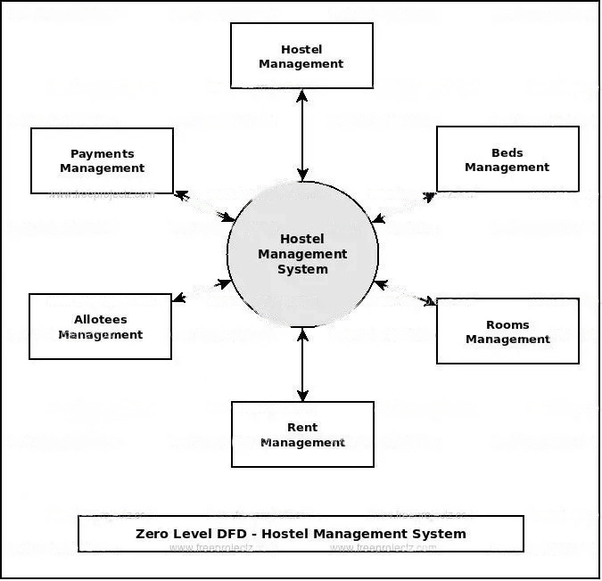

1-Level DFD:-

1. Processing Hostel records and generate report of all Hostel
2. Processing Beds records and generate report of all Beds
3. Processing Rooms records and generate report of all Rooms
4. Processing Rent records and generate report of all Rent
5. Processing Allotees records and generate report of all Allotees
6. Processing Payments records and generate report of all Payments
7. Processing Hostel Facility records and generate report of all Hostel Facility

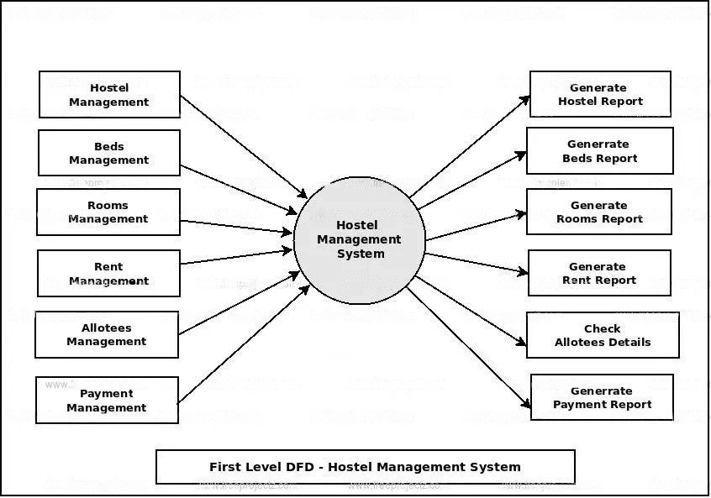

2-Level DFD:-

﻿

1. Admin logins to the system and manage all the functionalities of Hostel Management System
2. Admin can add, edit, delete and view the records of Hostel, Rooms, Allotees, Hostel Facility
3. Admin can manage all the details of Beds, Rent, Payments
4. Admin can also generate reports of Hostel, Beds, Rooms, Rent, Allotees, Payments
5. Admin can search the details of Beds, Allotees, Payments
6. Admin can apply different level of filters on report of Hostel, Rent, Allotees
7. Admin can tracks the detailed information of Beds, Rooms, Rent,, Allotees

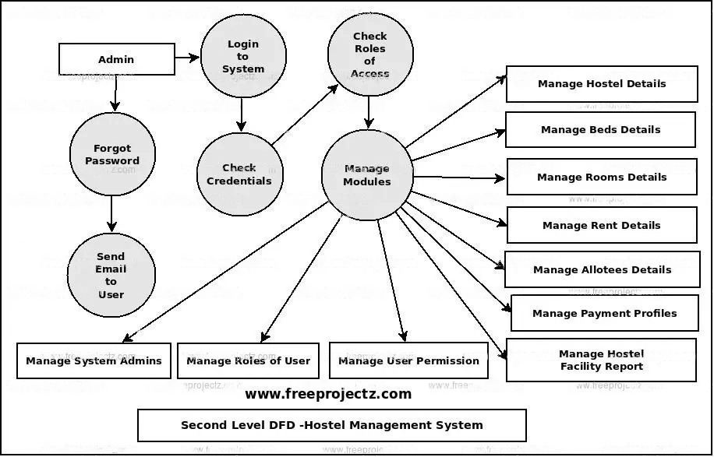

**BIBLIOGRAPHY**

* <http://www.google.com>
* <http://www.freeprojectz.com>
* <http://www.emarketer.com>

**REFERENCE**

* <https://www.w3schools.com>
* <https://www.google.com>
* https://www.geeksforgeeks.org/web-development
* https://www.freeprojectz.com/

**Faculty Guidelines**

Mr. Aakash Kumar Chaudhary

(Technical Trainer at GLA University)